**Use tourent web to access this file**

**Tourent upload**

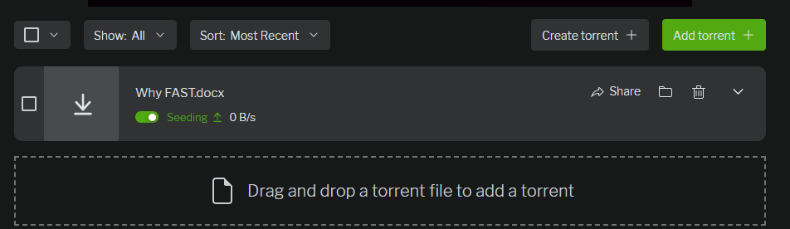

**Link send to other device from tourent**

<https://utweb.trontv.com/gui/share.html#link=magnet%3A%3Fxt%3Durn%3Abtih%3A4968e3c0488c9c9ba661fc71eac14b7db980a602%26dn%3DWhy%2520FAST.docx%26tr%3Dudp%253a%252f%252ftracker.openbittorrent.com%253a80%252fannounce%26tr%3Dudp%253a%252f%252ftracker.opentrackr.org%253a1337%252fannounce>

**from other device I have checked it from other device you can only access when my laptop is on seeding is on**

